Coding Standards Document – Default Company

Naming Conventions:
We will be utilizing Pascal Casing for our code implementation. This is in the form of MyVariable. We decided to utilize this because this is the default casing for C#.
Here are some examples of this in code.
Good Example
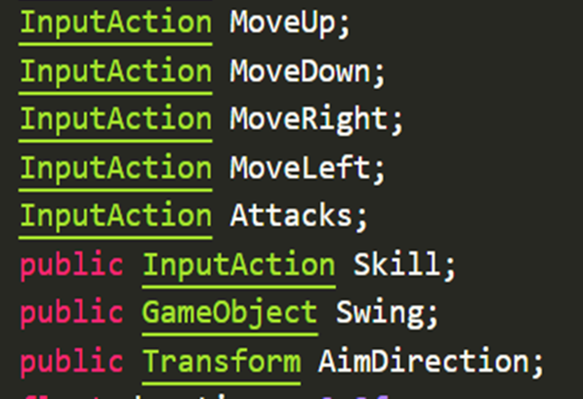
Bad Example (CamelCase)
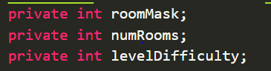

Commenting Styles:
We will be implementing comments into our code as we go using //comments above every piece of code that requires explanation. We will also be adding doxygen comments above our functions as a staple.
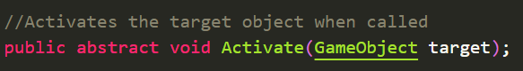
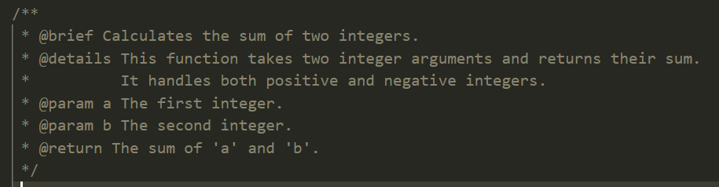

Error Handling:
We will be utilizing debug log comments within the code itself to easily figure out exactly where in the functions the program is breaking.
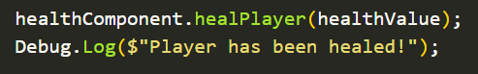

Indentation:
We will be using 3 tab rule for indentation. While this is a controversial decision, we wanted to choose a tab value that is somewhat in the middle of what most people are used to. 